Web development (5020)



NAME AND SURNAME | AGNES MAREDI
STUDENT NUMBER | ST10522799
GROUP | FOUR (4)
LECTURE NAME | MR DLAMINI
PROPOSAL | WEBSITE PROPOSAL
DATE OF SUBMISSION | 12 APRIL 2026

Table of contents
Background of organisation………………………………………………………….2
Website goals and objectives……………………………………………………….2
Proposed website features and functionality………………………………….3
Technical requirement…………………………………………………………………4
Design and user experience…………………………………………………………3
Project timeline………………………………………………………………………….5
Budget……………………………………………………………………………………..5
References……………………………………………………………………………….6

Target organisation
Small business
1) Name of organisation:
Espresso cafe
11) Background of organisation:
Espresso café was created to make coffee culture accessible to everyday South Africans and focusing on low-cost drinks and pastries (croissants, muffins, donuts and pies) but lastly fast service for people on the go. It became popular for offering affordable, quick coffee and baked goods at a fixed price point of R14 for every item.
Vision
We envision a future where everyone can enjoy high-quality coffee and fresh baked goods at accessible prices to grow the brand while maintaining commitment to affordability, efficiency and customer satisfaction.
Mission
We strive to provide fast, friendly service in convenient locations ensuring a nice experience while creating a welcoming environment.
Target audience
- Students
- Commuters
- Workers needing quick breakfast
2) Website goals and objectives
The goal of the espresso café website is to
- Promote the brand as a leading affordable coffee provider
- Provide essential information about its affordable coffee and pastry offerings
: The objectives include
- Increasing Store visits
- Improving customer awareness
- Delivering a user-friendly experience that allows customers to easily access menu, location and contact details.
Key performance indicators
Helps measure effectiveness of the websites:
- Website traffic
- Page views
- Average time on site
- Bounce rate
- Store visit conversions
- Contact engagement
- Mobile usability
3) Current website analysis
Strengths:
- Top notch customer service
- Innovation
- Quality of products
Weaknesses:
- Variable design and seasonality
- Limited operating hours
- High running costs

4) Proposed website features and functionality
- Home page: welcoming introduction, clear branding and tagline, highlights of key
Offerings and promotions

- About page: Background information, Brand story, mission, vision, builds trust and
Brand identity

- Contact page: phone number, email contact details, enquiry form for customer
questions
- Menu page: List of coffee and pastry items, simple pricing display, readable
- Location: information on store location, operating hours

5) Design and user experience
Colour scheme:
- Primary: deep brown
- Secondary: beige
- Accent: light caramel
- Text colour: black
Typography:
- Headings: bold sans
- Body text: arial
- Styles: consistent spacing and clear history between headings and paragraphs
User Experience:
- Simple efficient
- Easy navigation
- Fast loading time
- Mobile responsiveness

6) Technical Requirements
- Hosting: GitHub pages
- Domain: www.espressocafe.co.za
Programming Languages:
- HTML5: Structure and content
- CSS3: Styling, layout and design
- JavaScript: inactivity such as navigation menu
Frameworks and tools:
- Vs code: main development environment
- GitHub: version control and hosting
- Font awesome: for icons
- Google Fonts: modern and readability
Wireframe:

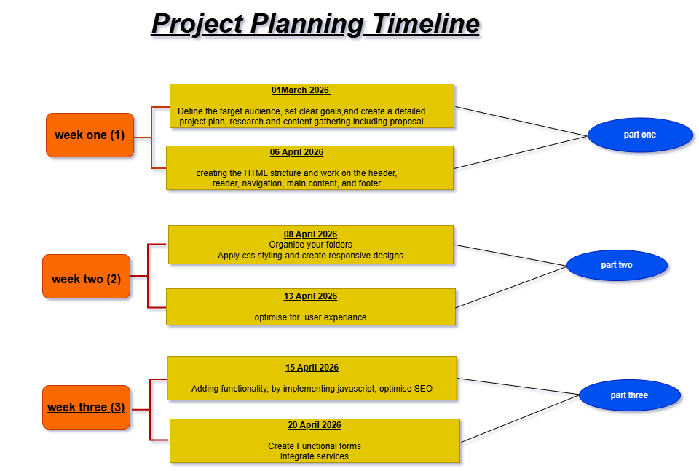
8) Budget

Hosting: R0 (free) GitHub pages
Domain: R0 – R200 subdomain
Tools: R0 (free) vs code, html, CSS, JS
Templets: R0 (free)
Images: R0 (free) free stock photos
Estimated to total R0 – R200 per year

REFERENCES

- MDN Web Docs (n.d.) HTML, CSS, and JavaScript documentation. Available at: https://developer.mozilla.org (Accessed: 12 April 2026).
- W3Schools (n.d.) Web development tutorials. Available at: https://www.w3schools.com (Accessed: 12 April 2026).
- GitHub (n.d.) GitHub Pages. Available at: https://pages.github.com (Accessed: 12 April 2026).
- Netlify (n.d.) Netlify Documentation. Available at: https://docs.netlify.com (Accessed: 12 April 2026).
- Nielsen Norman Group (n.d.) User experience principles. Available at: https://www.nngroup.com (Accessed: 12 April 2026).
- Google (n.d.) Google Fonts. Available at: https://fonts.google.com (Accessed: 12 April 2026).
- Font Awesome (n.d.) Font Awesome Icons. Available at: https://fontawesome.com (Accessed: 12 April 2026).
- Espresso Café (n.d.) Business concept and pricing model. (General research and educational sources).

